Python Interview Questions for Freshers
What is Python? What are the benefits of using Python
Python is a high-level, interpreted, general-purpose programming language.
Benefits of using Python:
- Python is a simple, easy-to-learn syntax ,reduces the cost of program maintenance.
it is completely open-source, and supports third-party packages encouraging modularity and code reuse
=======================================================================================================================================================================================
1. What is __init__?
__init__ is a contructor method in Python and is automatically called to allocate memory when a new object is created.
All classes have a __init__ method associated with them.
It helps to differentiate the class variables and methods from local variables..

# class definition
class Student:
def __init__(self, fname, lname, age, section):
self.firstname = fname
self.lastname = lname
self.age = age
self.section = section

# creating a new object
stu1 = Student("Sara", "Ansh", 22, "A2")

=========================================================================================================================================================================================

2. What is the difference between Python Arrays and lists?
- Python arrays can store only one type of data (Arrays do not allow mixed data types) i.e., data type of array should be homogeneous. And it consumes less memory than lists.
- Python lists can store different types of data, i.e., data types of lists can be heterogeneous. It consumes large memory.
import array
Array example:
a = array.array('i', [1, 2, 3])
for i in a:
print(i, end=' ') #OUTPUT: 1 2 3
a = array.array('i', [1, 2, 'string']) #OUTPUT: TypeError: an integer is required (got type str)

List example:
a = [1, 2, 'string']
for i in a:
print(i, end=' ') #OUTPUT: 1 2 string
=========================================================================================================================================================================================

4. What is slicing in Python?
- slicing’ is taking parts of.
- Syntax for slicing is [start : stop : step]
- start is the starting index from where to slice a list or tuple
- stop is the ending index or where to sop.
- step is the number of steps to jump.
- Default value for start is 0, stop is number of items, step is 1.
- Slicing can be done on strings, arrays, lists, and tuples.
numbers = [1, 2, 3, 4, 5, 6, 7, 8, 9, 10]
print(numbers[1 : : 2]) #output : [2, 4, 6, 8, 10] here output not mention that’s why taking till last
Example | Result

a[1:4] | = elements from index 1 to 3

a[:3] | = first 3 elements

a[2:] | = from index 2 to end

a[::-1] | = reverse sequence
A[1::2] = start from 2 till end

=========================================================================================================================================================================================

5. What is doc string in Python?
- Documentation string or docstring is a multiline string used to document a specific code segment.
- The docstring should describe what the function or method does.

Simple language :
A docstring is a multiline comment written inside triple quotes (""" """ or ''' ''') used to explain what a piece of code does.
- It helps other programmers understand the code easily.
maily used is :
A docstring describes what a function or method does.
It explains:
- purpose of the function
- what it returns
- sometimes what parameters it takes

=========================================================================================================================================================================================

6. What are unit tests in Python?
- Unit test is a unit testing framework of Python.(nothing but pytest)
- Unit testing means testing different components of software separately. Can you think about why unit testing is important? Imagine a scenario, you are building software that uses three components namely A, B, and C. Now, suppose your software breaks at a point time. How will you find which component was responsible for breaking the software? Maybe it was component A that failed, which in turn failed component B, and this actually failed the software. There can be many such combinations.
- This is why it is necessary to test each and every component properly so that we know which component might be highly responsible for the failure of the software.

Unit Testing is the first level of software testing where the smallest testable parts of the software are tested.
This is used to validate that each unit of the software performs as designed.
The unit test framework is Python’s xUnit style framework. The White Box Testing method is used for Unit testing.

=========================================================================================================================================================================================

7. What is break, continue and pass in Python?
Break | The break statement terminates the loop immediately and the control flows to the statement after the body of the loop.
Continue | The continue statement terminates the current iteration of the statement, skips the rest of the code in the current iteration and the control flows to the next iteration of the loop.
Pass | As explained above, the pass keyword in Python is generally used to fill up empty blocks and is similar to an empty statement represented by a semi-colon in languages such as Java, C++, Javascript, etc.

OR

- Break statement is used to terminate the loop or statement in which it is present. After that, the control will pass to the statements that are present after the break statement, if available.
- Continue . continue statement is opposite to that of the break statement, instead of terminating the loop, it forces to execute the next iteration of the loop. It is also a loop control statement just like the break statement
- Pass means performing no operation or in other words, it is a placeholder in the compound statement, where there should be a blank left and nothing has to be written there.

pat = [1, 3, 2, 1, 2, 3, 1, 0, 1, 3]
for p in pat:
pass
if (p == 0):
current = p
break
elif (p % 2 == 0):
continue
print(p) # output => 1 3 1 3 1
print(current) # output => 0
=========================================================================================================================================================================================

8. What is the use of self in Python?
Self is used to represent the instance of the class.
With self-keyword, you can access the attributes and methods of the class in python.
It binds the attributes with the given arguments. self is used in different places and often thought to be a keyword. But unlike in C++, self is not a keyword in Python.
=========================================================================================================================================================================================

9. What are global, protected and private attributes in Python?
- Global variables are public variables that are defined in the global scope. To use the variable in the global scope inside a function, we use the global keyword.
- Protected attributes are attributes defined with an underscore prefixed to their identifier eg. _sara. They can still be accessed and modified from outside the class they are defined in but a responsible developer should refrain from doing so.
- Private attributes are attributes with double underscore prefixed to their identifier eg. __ansh. They cannot be accessed or modified from the outside directly and will result in an AttributeError if such an attempt is made.
=========================================================================================================================================================================================

10. What are modules and packages in Python?
A module is a single file that contains Python code (functions, variables, classes) which can be reused in other programs. You can think of it as a code library. For example: math is a built-in module that provides math functions like sqrt(), pi, etc.
import math
print(math.sqrt(16))
Output
4.0

package is a collection of related modules stored in a directory. It helps in organizing and grouping modules together for easier management. For example: The numpy package contains multiple modules for numerical operations.
To create a package, the directory must contain a special file named __init__.py.

------

Python packages and modules are two mechanisms that allow for modular programming in Python.
Modularizing has several advantages -
- Simplicity: Working on a single module helps you focus on a relatively small portion of the problem at hand. This makes development easier and less error-prone.
- Maintainability: Modules are designed to enforce logical boundaries between different problem domains. If they are written in a manner that reduces interdependency, it is less likely that modifications in a module might impact other parts of the program.
- Reusability: Functions defined in a module can be easily reused by other parts of the application.
- Scoping: Modules typically define a separate namespace, which helps avoid confusion between identifiers from other parts of the program.

Modules, in general, are simply Python files with a .py extension and can have a set of functions, classes, or variables defined and implemented. They can be imported and initialized once using the import statement. If partial functionality is needed, import the requisite classes or functions using from foo import bar.

Packages allow for hierarchial structuring of the module namespace using dot notation. As, modules help avoid clashes between global variable names, in a similar manner, packages help avoid clashes between module names.
Creating a package is easy since it makes use of the system's inherent file structure. So just stuff the modules into a folder and there you have it, the folder name as the package name. Importing a module or its contents from this package requires the package name as prefix to the module name joined by a dot.
Note: You can technically import the package as well, but alas, it doesn't import the modules within the package to the local namespace, thus, it is practically useless.
=========================================================================================================================================================================================

11. What is pass in Python?
The pass keyword represents a null operation in Python.
- The pass statement is a placeholder that does nothing.
- Commonly used when defining empty functions, classes or loops during development.

It is generally used for the purpose of filling up empty blocks of code which may execute during runtime but has yet to be written.
Without the pass statement in the following code, we may run into some errors during code execution.

def myEmptyFunc():
# do nothing
pass
myEmptyFunc() # nothing happens

## Without the pass keyword
# File "<stdin>", line 3
# IndentationError: expected an indented block.
=========================================================================================================================================================================================

12. What are the common built-in data types in Python?
There are several built-in data types in Python.
Python does not require you to declare the data type when creating a variable. Python automatically understands the type. But if you mix incompatible data types, you may get type errors.
Python provides type() and isinstance() functions to check the type of these variables.
These data types can be grouped into the following categories-

- None Type:
None keyword represents the null values in Python. Boolean equality operation can be performed using these NoneType objects.
Class Name | Description
NoneType | Represents the NULL values in Python.
- Numeric Types:
There are three distinct numeric types - integers, floating-point numbers, and complex numbers. Additionally, booleans are a sub-type of integers.
Class Name | Description
int | Stores integer literals including hex, octal and binary numbers as integers
float | Stores literals containing decimal values and/or exponent signs as floating-point numbers
complex | Stores complex numbers in the form (A + Bj) and has attributes: real and imag
bool | Stores boolean value (True or False).
Note: The standard library also includes fractions to store rational numbers and decimal to store floating-point numbers with user-defined precision.

- Sequence Types:
According to Python Docs, there are three basic Sequence Types - lists, tuples, and range objects. Sequence types have the in and not in operators defined for their traversing their elements. These operators share the same priority as the comparison operations.
Class Name | Description
list | Mutable sequence used to store collection of items.
tuple | Immutable sequence used to store collection of items.
range | Represents an immutable sequence of numbers generated during execution.
str | Immutable sequence of Unicode code points to store textual data.
Note: The standard library also includes additional types for processing:
1. Binary data such as bytearray bytes memoryview , and
2. Text strings such as str.

- Mapping Types:
A mapping object can map hashable values to random objects in Python. Mappings objects are mutable and there is currently only one standard mapping type, the dictionary.
Class Name | Description
dict | Stores comma-separated list of key: value pairs
- Set Types:
Currently, Python has two built-in set types - set and frozenset. set type is mutable and supports methods like add() and remove(). frozenset type is immutable and can't be modified after creation.
Class Name | Description
set | Mutable unordered collection of distinct hashable objects.
frozenset | Immutable collection of distinct hashable objects.
Note: set is mutable and thus cannot be used as key for a dictionary. On the other hand, frozenset is immutable and thus, hashable, and can be used as a dictionary key or as an element of another set.
- Modules:
Module is an additional built-in type supported by the Python Interpreter. It supports one special operation, i.e., attribute access: mymod.myobj, where mymod is a module and myobj references a name defined in m's symbol table. The module's symbol table resides in a very special attribute of the module __dict__, but direct assignment to this module is neither possible nor recommended.
- Callable Types:
Callable types are the types to which function call can be applied. They can be user-defined functions, instance methods, generator functions, and some other built-in functions, methods and classes.
Refer to the documentation at docs.python.org for a detailed view of the callable types.

=========================================================================================================================================================================================

13. What are lists and tuples? What is the key difference between the two?
Lists and Tuples are both sequence data types that can store a collection of objects in Python.

Let’s analyze the differences between List and Tuple:
List:
- Lists are Mutable datatype.
- Lists consume more memory
- The list is better for performing operations, such as insertion and deletion.
- The implication of iterations is Time-consuming
Tuple:
- Tuples are Immutable datatype.
- Tuple consumes less memory as compared to the list
- A Tuple data type is appropriate for accessing the elements
- The implication of iterations is comparatively Faster.

You can run the following example on Python IDLE to confirm the difference:
my_tuple = ('sara', 6, 5, 0.97)
my_list = ['sara', 6, 5, 0.97]
print(my_tuple[0]) # output => 'sara'
print(my_list[0]) # output => 'sara'
my_tuple[0] = 'ansh' # modifying tuple => throws an error
my_list[0] = 'ansh' # modifying list => list modified
print(my_tuple[0]) # output => 'sara'
print(my_list[0]) # output => 'ansh'
=========================================================================================================================================================================================

14. What is Scope in Python?
Every object in Python functions within a scope.
A scope is a block of code where an object in Python remains relevant.
Namespaces uniquely identify all the objects inside a program. However, these namespaces also have a scope defined for them where you could use their objects without any prefix.
A few examples of scope created during code execution in Python are as follows:
- A local scope refers to the local objects available in the current function.
- A global scope refers to the objects available throughout the code execution since their inception.
- A module-level scope refers to the global objects of the current module accessible in the program.
- An outermost scope refers to all the built-in names callable in the program. The objects in this scope are searched last to find the name referenced.
Note: Local scope objects can be synced with global scope objects using keywords such as global.
=========================================================================================================================================================================================

15. What is PEP 8 and why is it important?
PEP stands for Python Enhancement Proposal.
A PEP is an official design document providing information to the Python community, or describing a new feature for Python or its processes.
PEP 8 is especially important since it documents the style guidelines for Python Code.
Apparently contributing to the Python open-source community requires you to follow these style guidelines sincerely and strictly.
=========================================================================================================================================================================================

16. What is an Interpreted language?
An Interpreted language executes its statements line by line. (it means it will read the code line by line .) #eksath sagla code complie nai karat
Languages such as Python, Javascript, R, PHP, and Ruby are prime examples of Interpreted languages.
Programs written in an interpreted language runs directly from the source code, with no intermediary compilation step.
=========================================================================================================================================================================================

17. What is a dynamically typed language?
Before we understand a dynamically typed language, we should learn about what typing is. Typing refers to type-checking in programming languages. In a strongly-typed language, such as Python, "1" + 2 will result in a type error since these languages don't allow for "type-coercion" (implicit conversion of data types). On the other hand, a weakly-typed language, such as Javascript, will simply output "12" as result.
Type-checking can be done at two stages -
- Static - Data Types are checked before execution.
- Dynamic - Data Types are checked during execution.
Python is an interpreted language, executes each statement line by line and thus type-checking is done on the fly, during execution. Hence, Python is a Dynamically Typed Language.
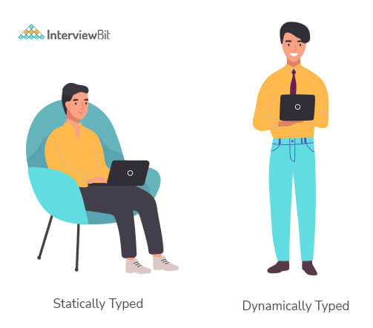
=========================================================================================================================================================================================

Python Interview Questions for Experienced

1. What are Dict and List comprehensions?
Python comprehensions, like decorators, are syntactic sugar constructs that help build altered and filtered lists, dictionaries, or sets from a given list, dictionary, or set.
Using comprehensions saves a lot of time and code that might be considerably more verbose (containing more lines of code).
Let's check out some examples, where comprehensions can be truly beneficial:

- Performing mathematical operations on the entire list
my_list = [2, 3, 5, 7, 11]
squared_list = [x**2 for x in my_list] # list comprehension
# output => [4 , 9 , 25 , 49 , 121]

squared_dict = {x:x**2 for x in my_list} # dict comprehension
# output => {11: 121, 2: 4 , 3: 9 , 5: 25 , 7: 49}

- Performing conditional filtering operations on the entire list
my_list = [2, 3, 5, 7, 11]
squared_list = [x**2 for x in my_list if x%2 != 0] # list comprehension
# output => [9 , 25 , 49 , 121]
squared_dict = {x:x**2 for x in my_list if x%2 != 0} # dict comprehension
# output => {11: 121, 3: 9 , 5: 25 , 7: 49}

- Combining multiple lists into one
Comprehensions allow for multiple iterators and hence, can be used to combine multiple lists into one.
a = [1, 2, 3]
b = [7, 8, 9]
[(x + y) for (x,y) in zip(a,b)] # parallel iterators
# output => [8, 10, 12]
[(x,y) for x in a for y in b] # nested iterators
# output => [(1, 7), (1, 8), (1, 9), (2, 7), (2, 8), (2, 9), (3, 7), (3, 8), (3, 9)]

- Flattening a multi-dimensional list
A similar approach of nested iterators (as above) can be applied to flatten a multi-dimensional list or work upon its inner elements.
my_list = [[10,20,30],[40,50,60],[70,80,90]]
flattened = [x for temp in my_list for x in temp]
# output => [10, 20, 30, 40, 50, 60, 70, 80, 90]
Note: List comprehensions have the same effect as the map method in other languages. They follow the mathematical set builder notation rather than map and filter functions in Python.
=========================================================================================================================================================================================

2. What are decorators in Python?
Decorators are a powerful and flexible way to modify or extend the behavior of functions or methods, without changing their actual code. A decorator is essentially a function that takes another function as an argument and returns a new function with enhanced functionality.
Decorators are often used in scenarios such as logging, authentication and memorization, allowing us to add additional functionality to existing functions or methods in a clean, reusable way.

Decorators in Python are functions that add extra functionality to another function without modifying the original function..(# excesting function madhe new modification kartat ,old code la touch na karta)
They are represented the @decorator_name in Python and are called in a bottom-up fashion.
For example:
# decorator function to convert to lowercase
def lowercase_decorator(function):
def wrapper():
func = function()
string_lowercase = func.lower()
return string_lowercase
return wrapper

# decorator function to split words
def splitter_decorator(function):
def wrapper():
func = function()
string_split = func.split()
return string_split
return wrapper
@splitter_decorator # this is executed next
@lowercase_decorator # this is executed first
def hello():
return 'Hello World'
hello() # output => [ 'hello' , 'world' ]

The beauty of the decorators lies in the fact that besides adding functionality to the output of the method, they can even accept arguments for functions and can further modify those arguments before passing it to the function itself. The inner nested function, i.e. 'wrapper' function, plays a significant role here. It is implemented to enforce encapsulation and thus, keep itself hidden from the global scope.
# decorator function to capitalize names
def names_decorator(function):
def wrapper(arg1, arg2):
arg1 = arg1.capitalize()
arg2 = arg2.capitalize()
string_hello = function(arg1, arg2)
return string_hello
return wrapper
@names_decorator
def say_hello(name1, name2):
return 'Hello ' + name1 + '! Hello ' + name2 + '!'
say_hello('sara', 'ansh') # output => 'Hello Sara! Hello Ansh!'

=========================================================================================================================================================================================

3. What is Scope Resolution in Python?
Sometimes objects within the same scope have the same name but function differently. In such cases, scope resolution comes into play in Python automatically. A few examples of such behavior are:
- Python modules namely 'math' and 'cmath' have a lot of functions that are common to both of them - log10(), acos(), exp() etc. To resolve this ambiguity, it is necessary to prefix them with their respective module, like math.exp() and cmath.exp().
- Consider the code below, an object temp has been initialized to 10 globally and then to 20 on function call. However, the function call didn't change the value of the temp globally. Here, we can observe that Python draws a clear line between global and local variables, treating their namespaces as separate identities.

temp = 10 # global-scope variable
def func():
temp = 20 # local-scope variable
print(temp)
print(temp) # output => 10
func() # output => 20
print(temp) # output => 10
This behavior can be overridden using the global keyword inside the function, as shown in the following example:
temp = 10 # global-scope variable
def func():
global temp
temp = 20 # local-scope variable
print(temp)
print(temp) # output => 10
func() # output => 20
print(temp) # output => 20
=========================================================================================================================================================================================

4. What are Python namespaces? Why are they used?
A namespace in Python ensures that object names in a program are unique and can be used without any conflict.
Python implements these namespaces as dictionaries with 'name as key' mapped to a corresponding 'object as value'.
This allows for multiple namespaces to use the same name and map it to a separate object.
A few examples of namespaces are as follows:
- Local Namespace includes local names inside a function. the namespace is temporarily created for a function call and gets cleared when the function returns.
- Global Namespace includes names from various imported packages/ modules that are being used in the current project. This namespace is created when the package is imported in the script and lasts until the execution of the script.
- Built-in Namespace includes built-in functions of core Python and built-in names for various types of exceptions.
The lifecycle of a namespace depends upon the scope of objects they are mapped to. If the scope of an object ends, the lifecycle of that namespace comes to an end. Hence, it isn't possible to access inner namespace objects from an outer namespace.
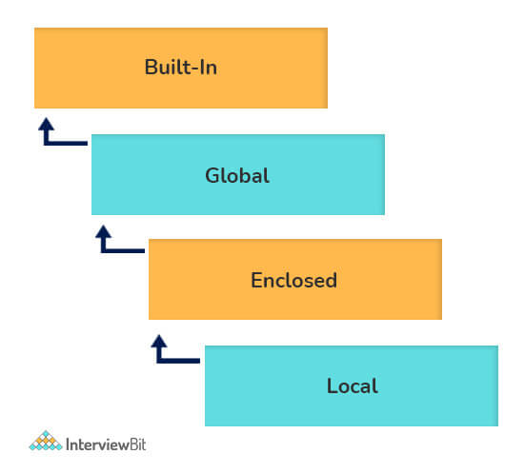
=========================================================================================================================================================================================

5. How is memory managed in Python?
- Memory management in Python is handled by the Python Memory Manager.
- The memory allocated by the manager is in form of a private heap space dedicated to Python.
- All Python objects are stored in this heap and being private, it is inaccessible to the programmer.
- Though, python does provide some core API functions to work upon the private heap space.
- Additionally, Python has an in-built garbage collection to recycle the unused memory for the private heap space.
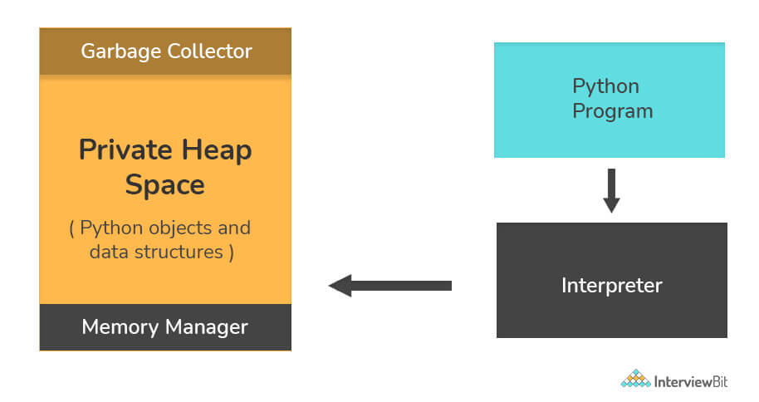

Python uses its private heap space to manage the memory. Basically, all the objects and data structures are stored in the private heap space. Even the programmer can not access this private space as the interpreter takes care of this space. Python also has an inbuilt garbage collector, which recycles all the unused memory and frees the memory and makes it available to the heap space.

=========================================================================================================================================================================================

6. What is lambda in Python? Why is it used?
Lambda is an anonymous function in Python, that can accept any number of arguments, but can only have a single expression.
It is generally used in situations requiring an anonymous function for a short time period.
Lambda functions can be used in either of the two ways:
- Assigning lambda functions to a variable:
add = lambda x, y: x + y
print(add(5, 3)) # Output: 8

- Wrapping lambda functions inside another function:
def myWrapper(n):
return lambda a : a * n
mulFive = myWrapper(5)
print(mulFive(2)) # output => 10
=========================================================================================================================================================================================

7. Explain how to delete a file in Python?
Use command os.remove(file_name)
import os
os.remove("ChangedFile.csv")
print("File Removed!")
=========================================================================================================================================================================================

8. What are negative indexes and why are they used?
- Negative indexes are the indexes from the end of the list or tuple or string.
- Arr[-1] means the last element of array Arr[]
arr = [1, 2, 3, 4, 5, 6]
#get the last element
print(arr[-1]) #output 6
#get the second last element
print(arr[-2]) #output 5
=========================================================================================================================================================================================

9. What does *args and **kwargs mean?
*args
- *args is aial syntax used in the function definition to pass variable-length arguments.
- “*” means variable length and “args” is the name used by convention. You can use any other.
def multiply(a, b, *argv):
mul = a * b
for num in argv:
mul *= num
return mul
print(multiply(1, 2, 3, 4, 5)) #output: 120

**kwargs
- **kwargs is a special syntax used in the function definition to pass variable-length keyworded arguments.
- Here, also, “kwargs” is used just by convention. You can use any other name.
- Keyworded argument means a variable that has a name when passed to a function.
- It is actually a dictionary of the variable names and its value.
def tellArguments(**kwargs):
for key, value in kwargs.items():
print(key + ": " + value)
tellArguments(arg1 = "argument 1", arg2 = "argument 2", arg3 = "argument 3")
#output:
# arg1: argument 1
# arg2: argument 2
# arg3: argument 3
=========================================================================================================================================================================================

10. Explain split() and join() functions in Python?
- You can use split() function to split a string based on a delimiter to a list of strings.
- You can use join() function to join a list of strings based on a delimiter to give a single string.

string = "This is a string."

string_list = string.split(' ') #delimiter is ‘space’ character or ‘ ‘
print(string_list)
#output: ['This', 'is', 'a', 'string.']

print(' '.join(string_list))
#output: This is a string.
=========================================================================================================================================================================================

11. What are iterators in Python?
(An iterator is an object that allows you to go through elements one by one in a sequence (like a list, tuple, or string).)
It remembers its state i.e., where it is during iteration (see code below to see how)
- __iter__() method initializes an iterator.
- It has a __next__() method which returns the next item in iteration and points to the next element. Upon reaching the end of iterable object __next__() must return StopIteration exception.
- It is also self-iterable.
Example :
numbers = [10, 20, 30]
it = iter(numbers) # create iterator

print(next(it))
print(next(it))
print(next(it))
#output
10
20
30
=========================================================================================================================================================================================

12. How are arguments passed by value or by reference in python?
- Pass by value: Copy of the actual object is passed. Changing the value of the copy of the object will not change the value of the original object.
- Pass by reference: Reference to the actual object is passed. Changing the value of the new object will change the value of the original object.
- Python’s argument-passing model is neither “Pass by Value” nor “Pass by Reference” but it is “Pass by Object Reference”.
- Depending on the type of object you pass in the function, the function behaves differently. Immutable objects show “pass by value” whereas mutable objects show “pass by reference”.

In Python, arguments are passed by reference, i.e., reference to the actual object is passed.
def appendNumber(arr):
arr.append(4)
arr = [1, 2, 3]
print(arr) #Output: => [1, 2, 3]
appendNumber(arr)
print(arr) #Output: => [1, 2, 3, 4]
=========================================================================================================================================================================================

13. How Python is interpreted?
- Python as a language is not interpreted or compiled. Interpreted or compiled is the property of the implementation. Python is a bytecode(set of interpreter readable instructions) interpreted generally.
- Source code is a file with .py extension.
- Python compiles the source code to a set of instructions for a virtual machine. The Python interpreter is an implementation of that virtual machine. This intermediate format is called “bytecode”.
- .py source code is first compiled to give .pyc which is bytecode. This bytecode can be then interpreted by the official CPython or JIT(Just in Time compiler) compiled by PyPy.
=========================================================================================================================================================================================

14. What is the difference between .py and .pyc files?
- .py files contain the source code of a program.(it is human readble)(it is used for write the code)
- .pyc file contains the bytecode of your program. (it is for machine ,)(it is for read the code)
- We get bytecode after compilation of .py file (source code).
- .pyc files are not created for all the files that you run. It is only created for the files that you import.
- Before executing a python program python interpreter checks for the compiled files. If the file is present, the virtual machine executes it. If not found, it checks for .py file. If found, compiles it to .pyc file and then python virtual machine executes it.
- Having .pyc file saves you the compilation time.
=========================================================================================================================================================================================

15. What is the use of help() and dir() functions?
help() function in Python is used to display the documentation of modules, classes, functions, keywords, etc. If no parameter is passed to the help() function, then an interactive help utility is launched on the console.
dir() function tries to return a valid list of attributes and methods of the object it is called upon. It behaves differently with different objects, as it aims to produce the most relevant data, rather than the complete information.
- For Modules/Library objects, it returns a list of all attributes, contained in that module.
- For Class Objects, it returns a list of all valid attributes and base attributes.
- With no arguments passed, it returns a list of attributes in the current scope.
=========================================================================================================================================================================================

16. What is PYTHONPATH in Python?
PYTHONPATH is an environment variable which you can set to add additional directories where Python will look for modules and packages. This is especially useful in maintaining Python libraries that you do not wish to install in the global default location.
=========================================================================================================================================================================================

17. What are generators in Python?
Generators are functions that return an iterable collection of items, one at a time, in a set manner.
Generators, in general, are used to create iterators with a different approach.
They employ the use of yield keyword rather than return to return a generator object.

In Python, the generator is a way that specifies how to implement iterators.
It is a normal function except that it yields expression in the function.
It does not implement __itr__ and __next__ method and reduces other overheads as well.
If a function contains at least a yield statement, it becomes a generator.
The yield keyword pauses the current execution by saving its states and then resumes from the same when required.

=========================================================================================================================================================================================

18. What is pickling and unpickling?
Python library offers a feature - serialization out of the box. Serializing an object refers to transforming it into a format that can be stored, so as to be able to deserialize it, later on, to obtain the original object. Here, the pickle module comes into play.
Pickling:
- Pickling is the name of the serialization process in Python. Any object in Python can be serialized into a byte stream and dumped as a file in the memory. The process of pickling is compact but pickle objects can be compressed further. Moreover, pickle keeps track of the objects it has serialized and the serialization is portable across versions.
- The function used for the above process is pickle.dump().
Unpickling:
- Unpickling is the complete inverse of pickling. It deserializes the byte stream to recreate the objects stored in the file and loads the object to memory.
- The function used for the above process is pickle.load().
Note: Python has another, more primitive, serialization module called marshall, which exists primarily to support .pyc files in Python and differs significantly from the pickle.
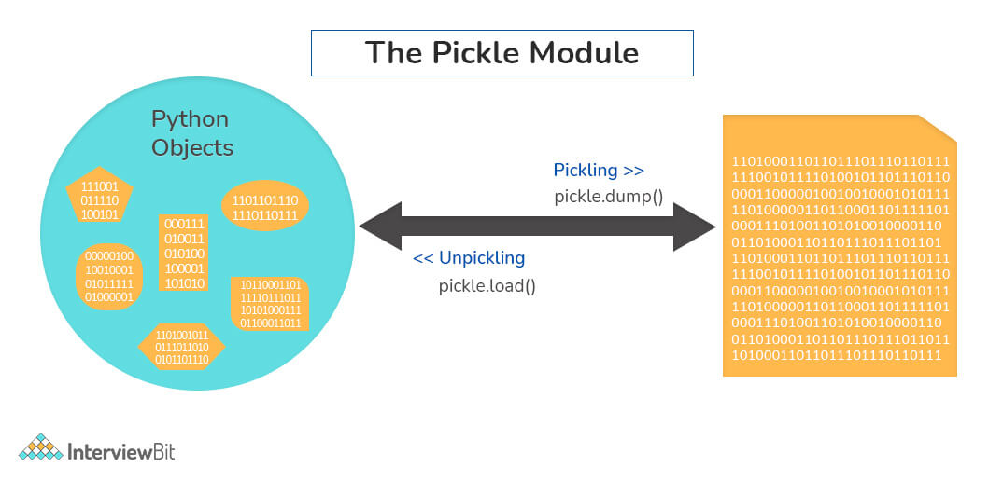

- Pickling: The pickle module converts any Python object into a byte stream (not a string representation). This byte stream can then be stored in a file, sent over a network, or saved for later use. The function used for pickling is pickle.dump().
- Unpickling: The process of retrieving the original Python object from the byte stream (saved during pickling) is called unpickling. The function used for unpickling is pickle.load().

=========================================================================================================================================================================================

19. What is the difference between xrange and range in Python?
xrange() and range() are quite similar in terms of functionality. They both generate a sequence of integers, with the only difference that range() returns a Python list, whereas, xrange() returns an xrange object.
So how does that make a difference? It sure does, because unlike range(), xrange() doesn't generate a static list, it creates the value on the go. This technique is commonly used with an object-type generator and has been termed as "yielding".
Yielding is crucial in applications where memory is a constraint. Creating a static list as in range() can lead to a Memory Error in such conditions, while, xrange() can handle it optimally by using just enough memory for the generator (significantly less in comparison).
for i in xrange(10): # numbers from o to 9
print i # output => 0 1 2 3 4 5 6 7 8 9
for i in xrange(1,10): # numbers from 1 to 9
print i # output => 1 2 3 4 5 6 7 8 9
for i in xrange(1, 10, 2): # skip by two for next
print i # output => 1 3 5 7 9
Note: xrange has been deprecated as of Python 3.x. Now range does exactly the same as what xrange used to do in Python 2.x, since it was way better to use xrange() than the original range() function in Python 2.x.
=========================================================================================================================================================================================

Python OOPS Interview Questions

Inheritance
Inheritance means one class can use the properties and methods of another class.
It allows a new class to reuse code from an existing class.
- A class can inherit properties/methods from another class.
- Example: class ElectricCar(Car):
- • Single Inheritance – एक subclass, एक parent class
- • Multiple Inheritance – एक subclass, अनेक parent classes
- • Multilevel Inheritance – chain of inheritance (grandparent → parent → child)
- • Hierarchical Inheritance – एक parent, अनेक subclasses
- • Hybrid Inheritance – combination of above types

Encapsulation
- Hiding internal data using private/protected attributes.
Encapsulation is widely used in banking, HR systems, healthcare apps—anywhere sensitive data like salaries, passwords, or account balances need protection.

Abstraction
- Show only necessary details, hide implementation.
- Example: Using methods like start_engine() without showing internal steps.

Abstraction is used in banking apps, e-commerce, and payment gateways to hide complex internal logic and show only necessary operations to the user.

Polymorphism
- Same interface, different implementation.
- Example: Method overriding or operator overloading.

Method Overloading / Overriding
- Overloading: Same method name, different parameters.
- Overriding: Subclass changes method behavior of parent class.

----------------------------------------------------------------------------------------

1. How will you check if a class is a child of another class?
This is done by using a method called issubclass() provided by python. The method tells us if any class is a child of another class by returning true or false accordingly.
For example:

class Parent(object):
pass

class Child(Parent):
pass

# Driver Code
print(issubclass(Child, Parent)) #True
print(issubclass(Parent, Child)) #False
- We can check if an object is an instance of a class by making use of isinstance() method:
obj1 = Child()
obj2 = Parent()
print(isinstance(obj2, Child)) #False
print(isinstance(obj2, Parent)) #True
=========================================================================================================================================================================================

3. Why is finalize used?
Finalize method is used to clean up things before an object is removed from memory.
Finalize method is used for freeing up the unmanaged resources and clean up before the garbage collection method is invoked.
This helps in performing memory management tasks.
=========================================================================================================================================================================================

4. Differentiate between new and override modifiers.
The new modifier is used to instruct the compiler to use the new implementation and not the base class function.
The Override modifier is useful for overriding a base class function inside the child class.
=========================================================================================================================================================================================

5. How is an empty class created in python?
An empty class does not have any members defined in it. It is created by using the pass keyword (the pass command does nothing in python).
We can create objects for this class outside the class.
=========================================================================================================================================================================================

6. Is it possible to call parent class without its instance creation?
Yes, it is possible if the base class is instantiated by other child classes or if the base class is a static method.
=========================================================================================================================================================================================

7. Are access specifiers used in python?
Python does not make use of access specifiers specifically like private, public, protected, etc. However, it does not derive this from any variables. It has the concept of imitating the behaviour of variables by making use of a single (protected) or double underscore (private) as prefixed to the variable names. By default, the variables without prefixed underscores are public.
Example:
# to demonstrate access specifiers
class InterviewbitEmployee:

# protected members
_emp_name = None
_age = None

# private members
__branch = None

# constructor
def __init__(self, emp_name, age, branch):
self._emp_name = emp_name
self._age = age
self.__branch = branch

#public member
def display():
print(self._emp_name +" "+self._age+" "+self.__branch)
=========================================================================================================================================================================================

8. How do you access parent members in the child class?
Following are the ways using which you can access parent class members within a child class:
- By using Parent class name: You can use the name of the parent class to access the attributes as shown in the example below:
class Parent(object):
# Constructor
def __init__(self, name):
self.name = name

class Child(Parent):
# Constructor
def __init__(self, name, age):
Parent.name = name
self.age = age

def display(self):
print(Parent.name, self.age)

# Driver Code
obj = Child("Interviewbit", 6)
obj.display()
- By using super(): The parent class members can be accessed in child class using the super keyword.
class Parent(object):
# Constructor
def __init__(self, name):
self.name = name

class Child(Parent):
# Constructor
def __init__(self, name, age):
'''
In Python 3.x, we can also use super().__init__(name)
'''
super(Child, self).__init__(name)
self.age = age

def display(self):
# Note that Parent.name cant be used
# here since super() is used in the constructor
print(self.name, self.age)

# Driver Code
obj = Child("Interviewbit", 6)
obj.display()
=========================================================================================================================================================================================

9. How does inheritance work in python? Explain it with an example.
Inheritance gives the power to a class to access all attributes and methods of another class.
It aids in code reusability and helps the developer to maintain applications without redundant code.
The class inheriting from another class is a child class or also called a derived class.
The class from which a child class derives the members are called parent class or superclass.
Python supports different kinds of inheritance, they are:

EASY Language :
Inheritance means one class can use the properties and methods of another class.
It allows a new class to reuse code from an existing class.”

- Single Inheritance: Child class derives members of one parent class.
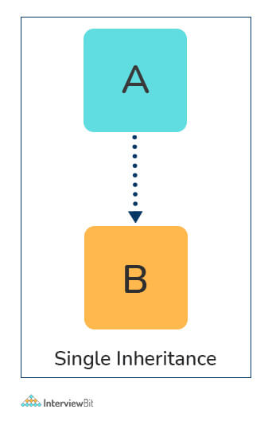
# Parent class
class ParentClass:
def par_func(self):
print("I am parent class function")

# Child class
class ChildClass(ParentClass):
def child_func(self):
print("I am child class function")

# Driver code
obj1 = ChildClass()
obj1.par_func()
obj1.child_func()

- Multi-level Inheritance: The members of the parent class, A, are inherited by child class which is then inherited by another child class, B.
- The features of the base class and the derived class are further inherited into the new derived class, C.
- Here, A is the grandfather class of class C.
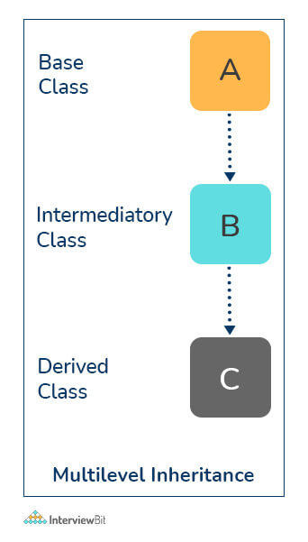
# Parent class
class A:
def __init__(self, a_name):
self.a_name = a_name

# Intermediate class
class B(A):
def __init__(self, b_name, a_name):
self.b_name = b_name
# invoke constructor of class A
A.__init__(self, a_name)

# Child class
class C(B):
def __init__(self,c_name, b_name, a_name):
self.c_name = c_name
# invoke constructor of class B
B.__init__(self, b_name, a_name)

def display_names(self):
print("A name : ", self.a_name)
print("B name : ", self.b_name)
print("C name : ", self.c_name)

# Driver code
obj1 = C('child', 'intermediate', 'parent')
print(obj1.a_name)
obj1.display_names()

- Multiple Inheritance: This is achieved when one child class derives members from more than one parent class. All features of parent classes are inherited in the child class.
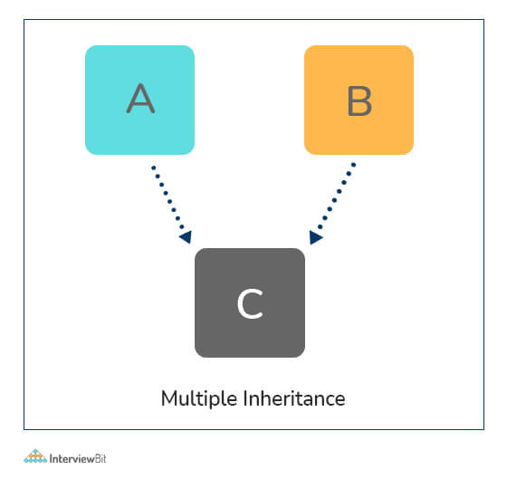
# Parent class1
class Parent1:
def parent1_func(self):
print("Hi I am first Parent")

# Parent class2
class Parent2:
def parent2_func(self):
print("Hi I am second Parent")

# Child class
class Child(Parent1, Parent2):
def child_func(self):
self.parent1_func()
self.parent2_func()

# Driver's code
obj1 = Child()
obj1.child_func()

- Hierarchical Inheritance: When a parent class is derived by more than one child class, it is called hierarchical inheritance.
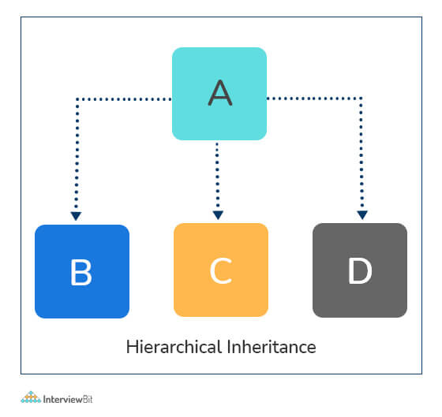
# Base class
class A:
def a_func(self):
print("I am from the parent class.")

# 1st Derived class
class B(A):
def b_func(self):
print("I am from the first child.")

# 2nd Derived class
class C(A):
def c_func(self):
print("I am from the second child.")

# Driver's code
obj1 = B()
obj2 = C()
obj1.a_func()
obj1.b_func() #child 1 method
obj2.a_func()
obj2.c_func() #child 2 method
=========================================================================================================================================================================================

